Assignment-30.3:

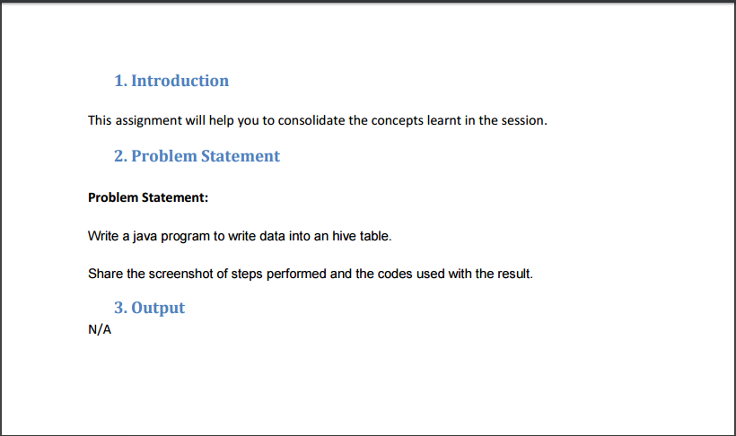

Input data: We will load this data into hive using java api

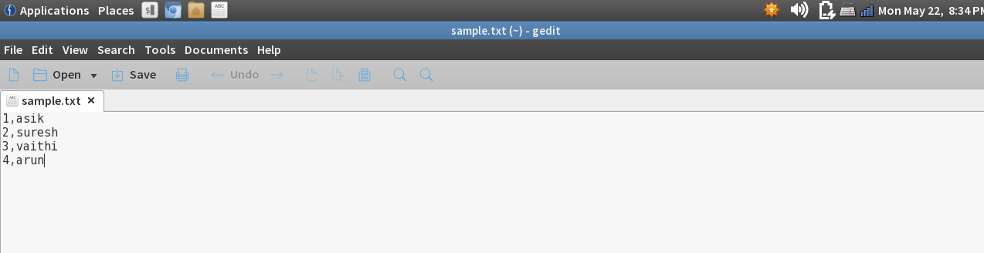

Setting the configurations in the hive-site.xml. The port number for the hiveserver 2 is set to 10000 and the mysql configurations like the username and password to connect to the mysql database are set.

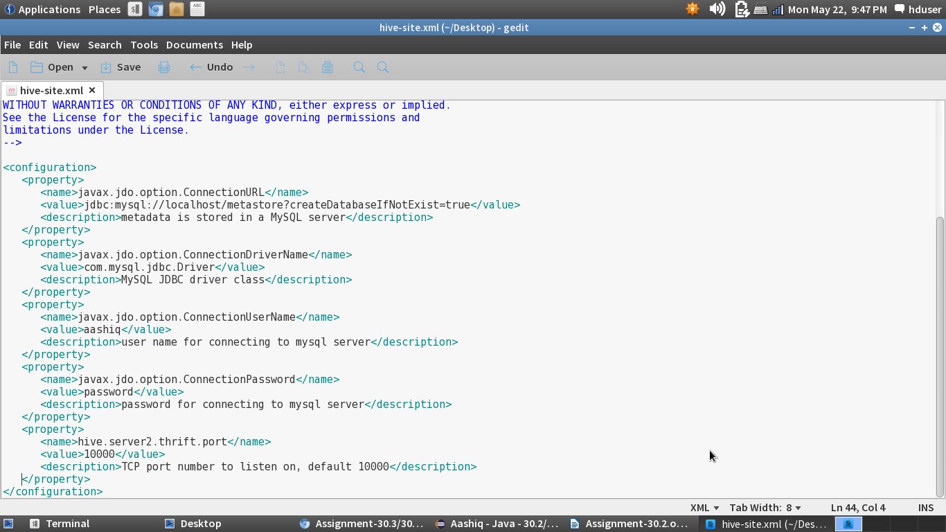

Starting the hiveserver2:

The hiveserver2 is started in the command line and we can see in the below screenshot the status of the data loaded into the hive.

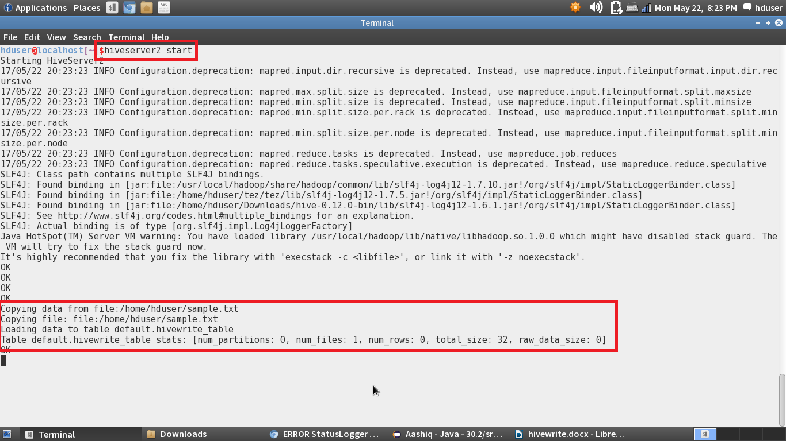

Java Program:

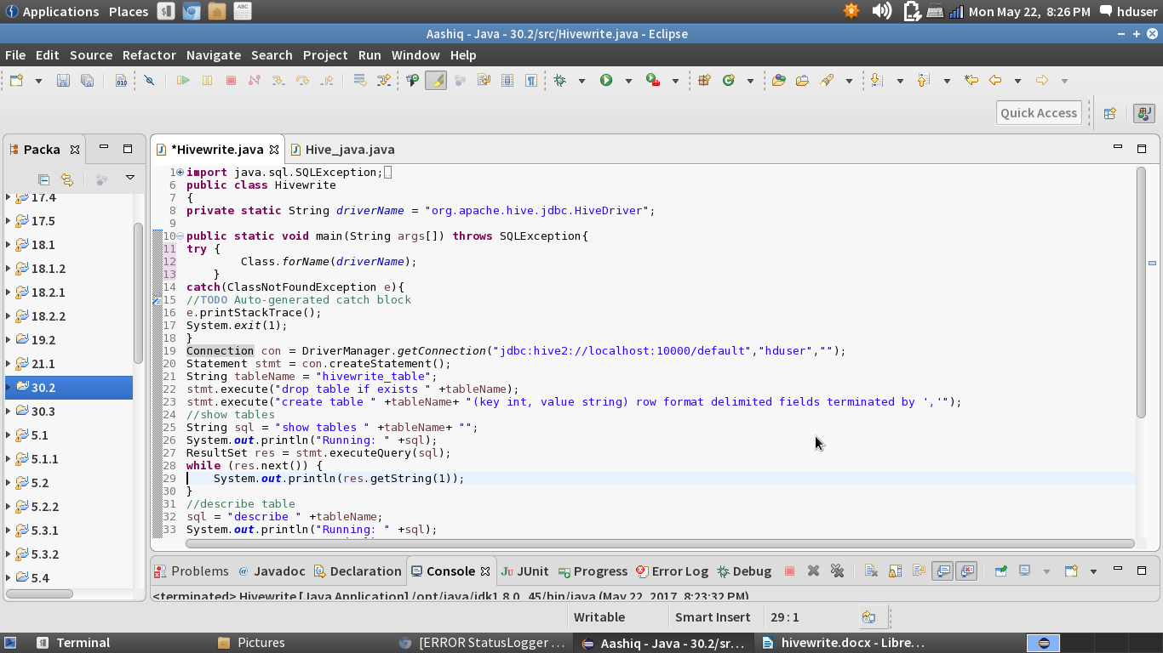

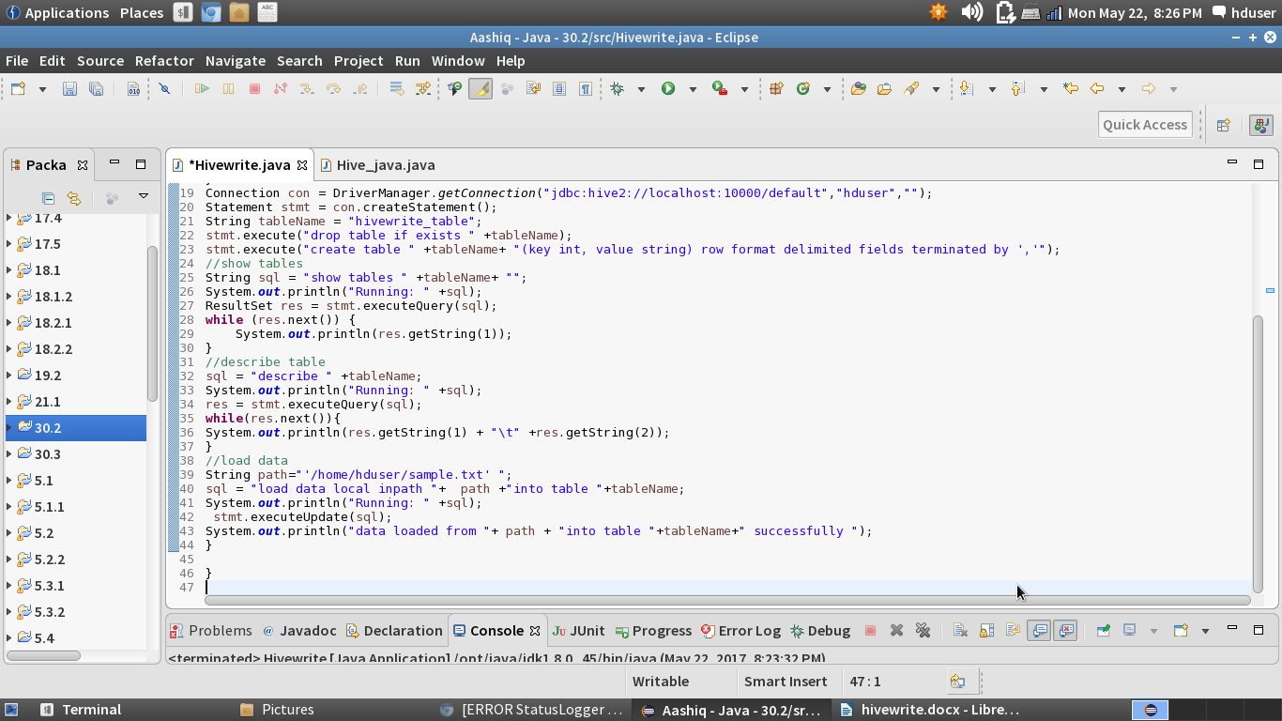

Eclipse Console: We can see that the data is loaded into the hive table

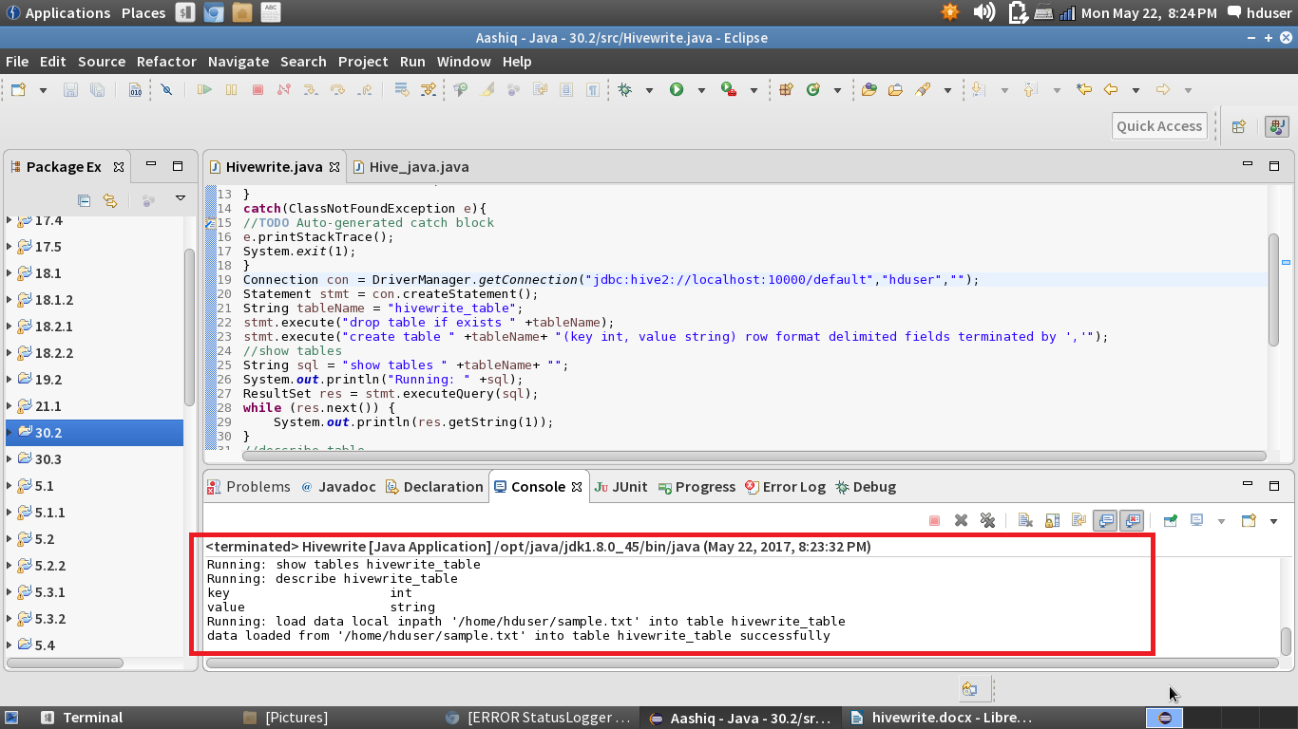

Checking whether the table is created abd the table is displayed.

